Unit 6 Website Development

Assignment 1

Oliver Collins-Cope

2022

Table of Contents

**No table of contents entries found.**

# Introduction

Throughout this assignment I will be discussing two different websites, Facebook and Twitter, and describing how they differ, comparing them based on different points such as usability, layout, navigation, content, readability, typography, accessibility, consistency and many more. These sites will be compared, analysed, and evaluated in order to determine how well they operate under the principles of website design in order to produce a fully functional and smooth experience for the user.

# Facebook

Facebook is a social media giant, remaining at the forefront of social media and is one of the most used websites, while also being the most used social media website by roughly 600 million users (Statista Research Department, 2022).

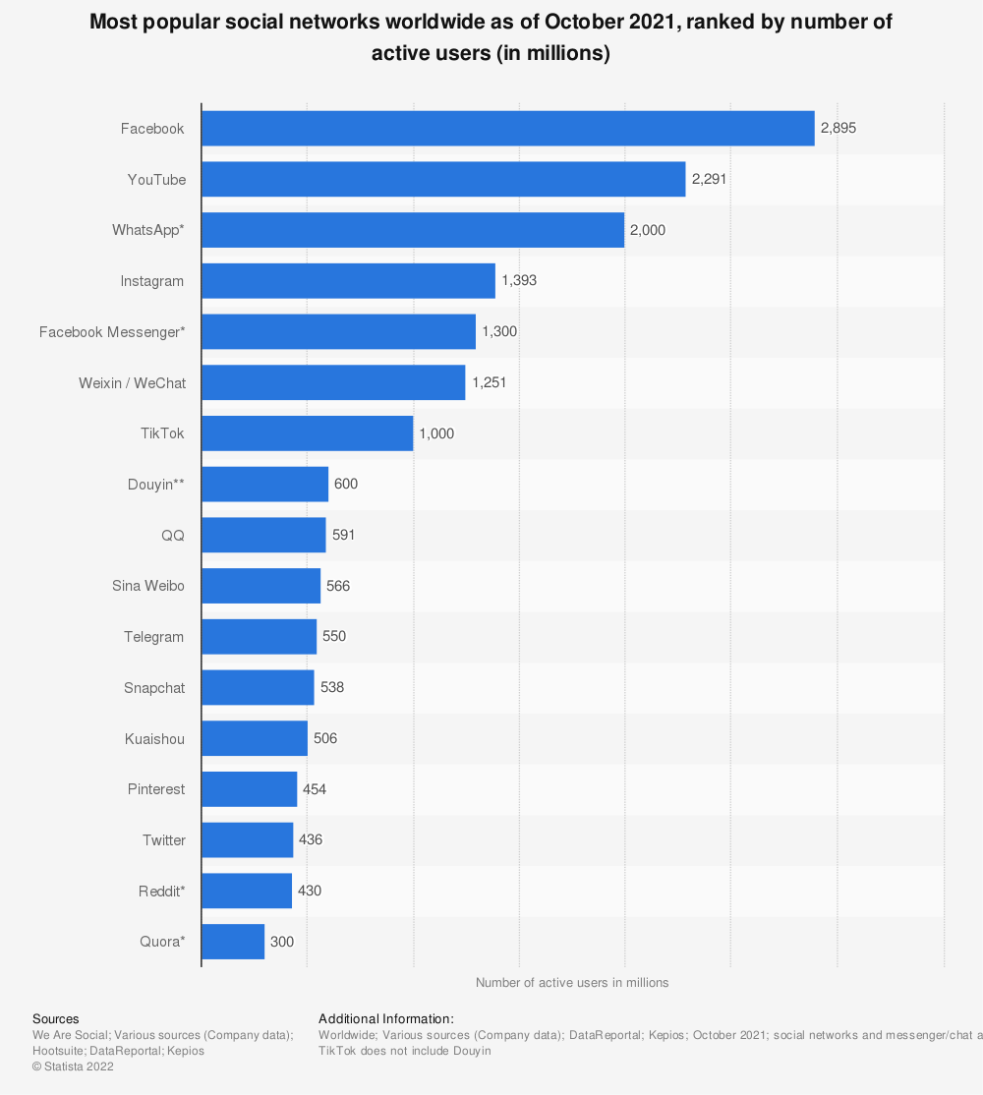

Facebook, being a social media platform, its primary purpose, for users, is to allow them to connect and interact with each other online, while also allowing users to view content for different pages they might follow, post their own content and statuses, as well as small games that the website supports - this last feature is unique to Facebook. Facebooks target audience are those in their mid-20’s to mid-30’s, as this is the most active Chart, bar chart
age group on Facebook by about 6% for males, and 3% for females.

# Bibliography

Statista Research Department. (2022). *Statista*. Retrieved February 1, 2022, from https://www.statista.com/statistics/272014/global-social-networks-ranked-by-number-of-users/